Open in app or online

The well supplied US Army in North Africa

20th March 1943: A British war correspondent is impressed by the quantity and quality of American equipment and supplies
MAR 20

SAVE |  | ▷ LISTEN

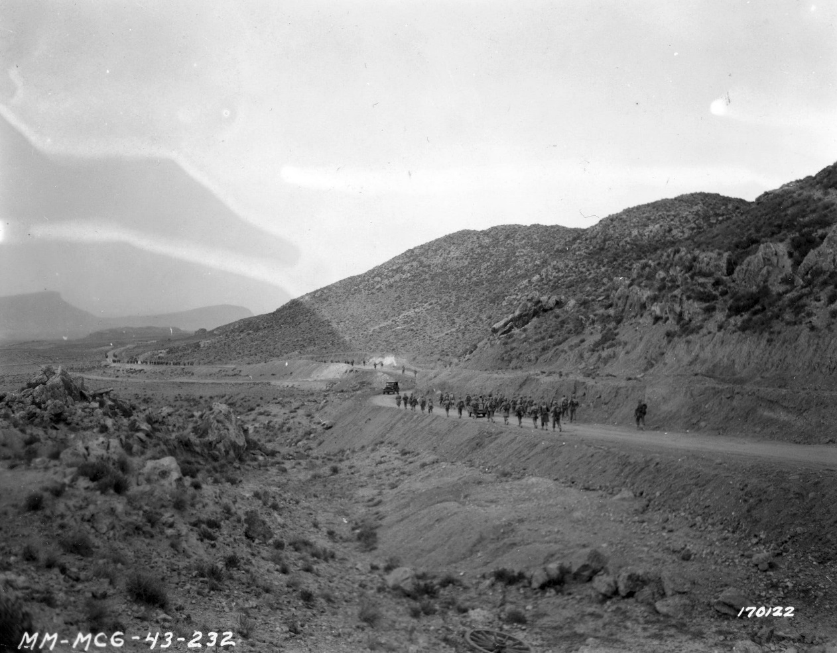
US infantry marching through Tunisia. They follow a reconnaissance unit which has cleared the fields of mines. 26 February, 1943. 2nd Battalion, 16th Infantry Regiment, 1st Infantry Division
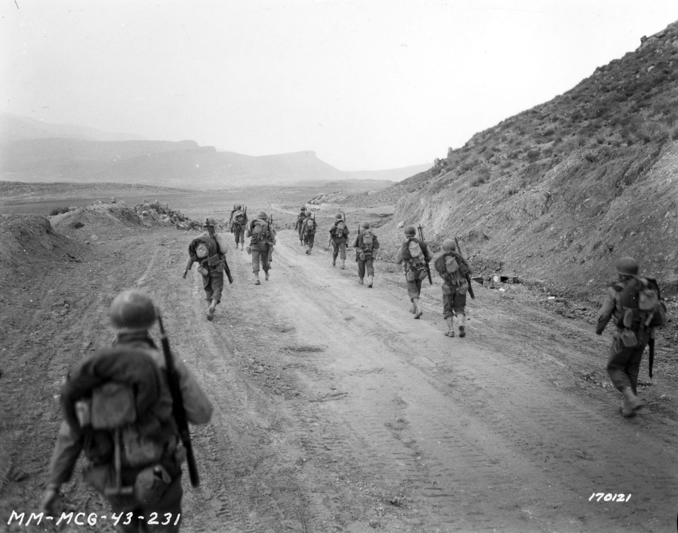
2nd Bn. 16th Inf., marching through the Kasserine Pass, on to Kasserine and Farriana. Visa looking out east toward Kasserine through the pass. 26 February, 1943
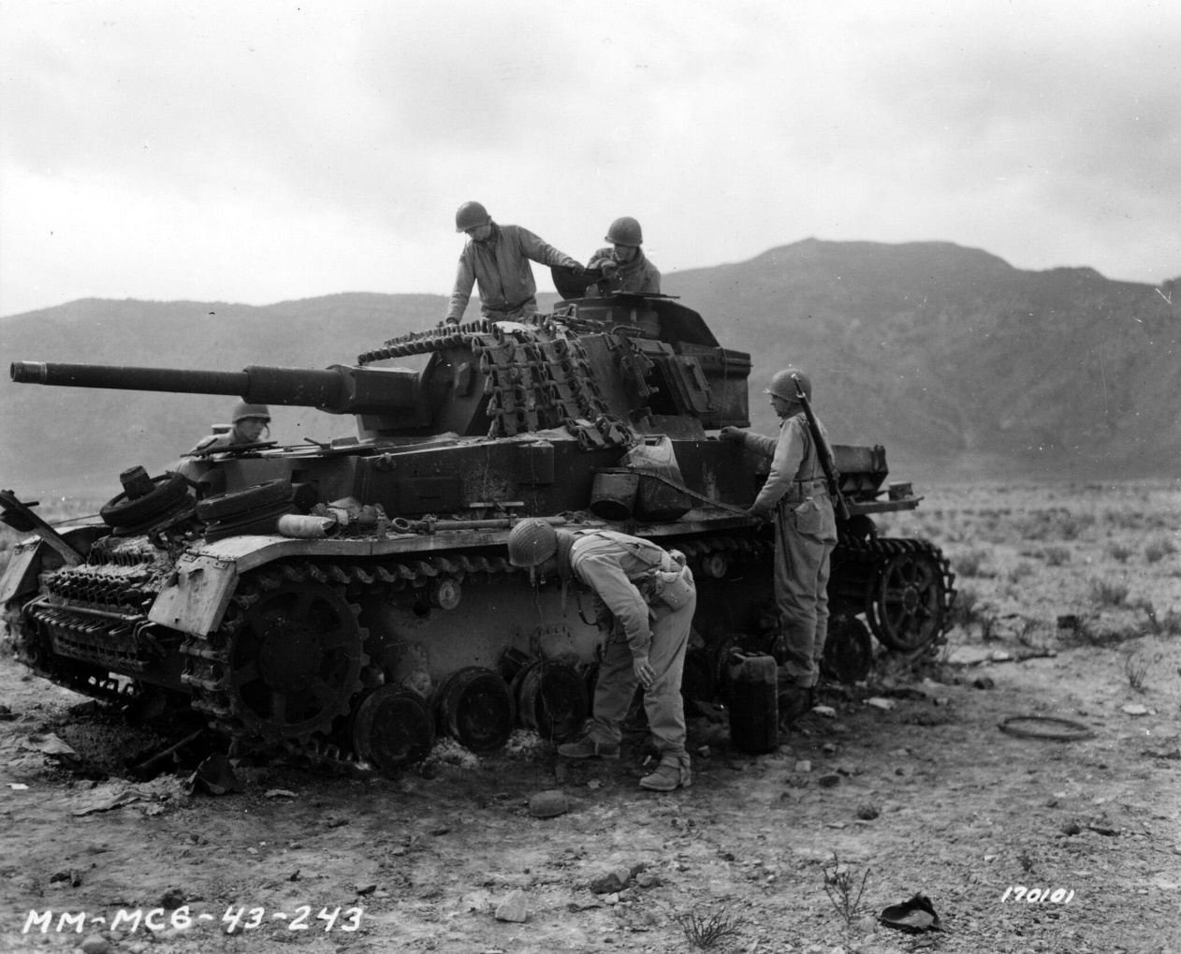
A German Mark IV tank knocked out by American artillery fire. One shot entered the tank, exploded and blew up the ammunition carried by the tank. The interior and motors were completely demolished. 26 February, 1943. Kasserine Pass, Tunisia.
British war correspondent Alan Moorehead¹ had been in the desert from the very beginning. His classic account of the campaign in North Africa is full of incidental detail, painting a vivid picture of what life was like in the field.
It was the volume of this stuff, the intensity of the firepower that was so impressive. Possibly the troops could have done with a better heavy machine gun and an improved mortar, but in general, there was no question that they were the best-equipped allied army at the front.
In mid-March he learnt that US forces were poised for a new attack in the west of Tunisia, squeezing the Germans as the 8th Army made their assault in the southeast.
Moorehead took the opportunity to visit the US troops on the eve of battle:
In the drizzling rain little groups of infantrymen were drawn up to receive their last instructions. They were hardly more than boys, most of them, wonderfully tall and proportioned and looking very forbidding under their Nazi-like helmets.
Unlike the British battledress and equipment, which tends to hold a man stiffly upright, these boys were in a uniform which gave them plenty of free movement. The short and formless weatherproof jacket was scarcely a garment of beauty, but it allowed the men to walk in the easy stooping way to which they were accustomed.
Most of the American stuff was first-class, and even as good or better than the German. Their mess tins, water bottles, rubber-soled boots, woollen underclothes, shirts and windbreakers were all superior to the British equivalents and their uniforms in general were made of finer stuff.
The Garand rifle and the officers’ carbine were already regarded by many veterans as the best small arms on the front. As for their heavier equipment, it is doubtful if any army ever went to war so well supplied.
By European army standards the American rations were lavish to the point of extravagance - vast quantities of tinned meats, fruits and vegetables. In any American mess you could be sure of getting an excellent hot meat and vegetable stew, a plate of fruit, white bread and a cup of coffee.
The only general criticism might have been that there was too much of it. Every other truck had a machine-gun mounted on its cabin. The self-propelling guns and the Long Tom guns were some of the heaviest artillery along the whole front. The diesel Sherman was certainly the best tank of its class.
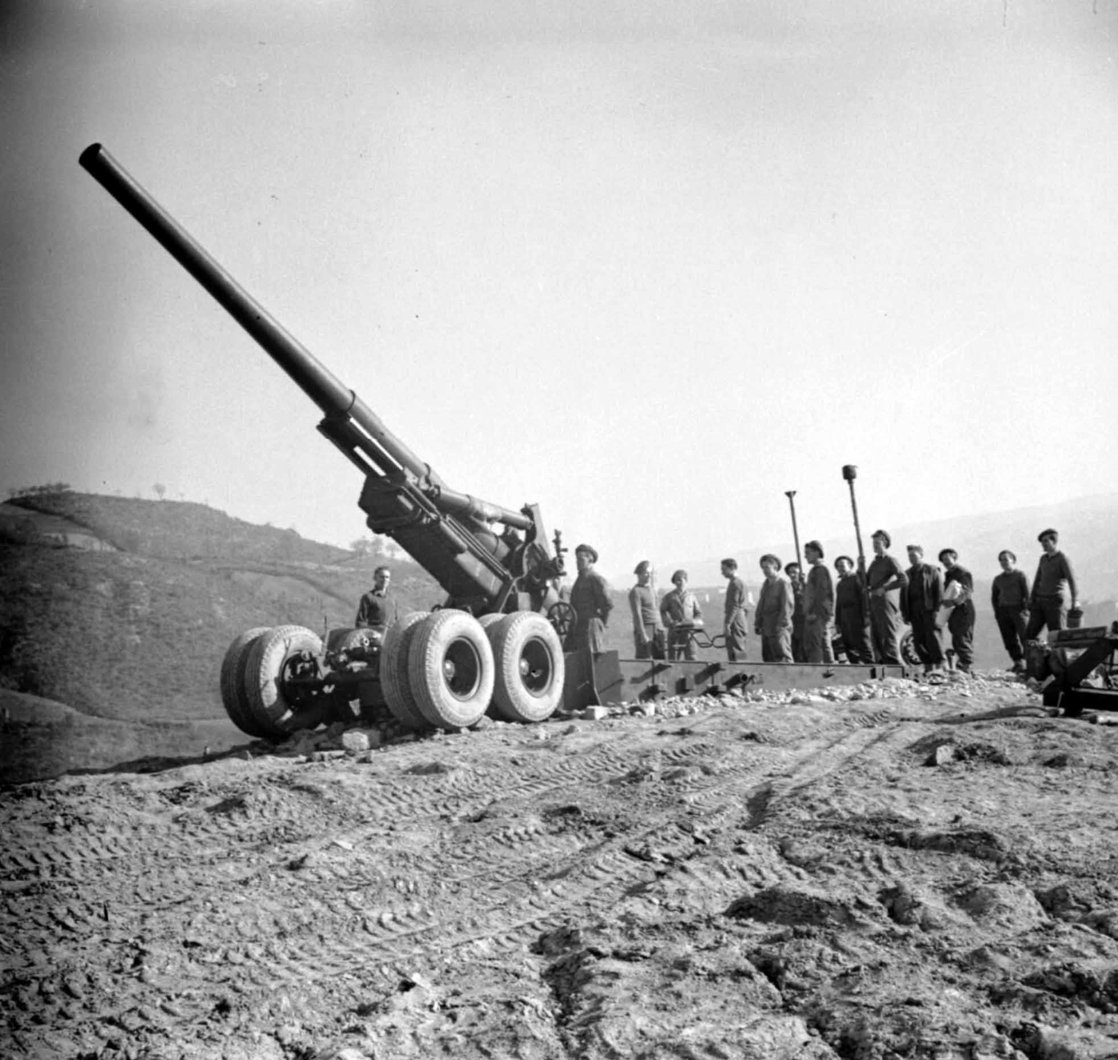
An American-built 155mm 'Long Tom' gun of 33/61 Heavy Regiment, Royal Artillery, at Vergato, 22 February 1945.
The jeeps, at the other end of the scale, were unmatched, and the Gernans loved to capture them for their own use, just as we had loved to get hold of a Volkswagen. The weapon-carriers and the command vehicles were all brand new, as were the signalling sets, the bulldozers for road-mending, and the electrical workshops.
It was the volume of this stuff, the intensity of the firepower that was so impressive. Possibly the troops could have done with a better heavy machine-gun and an improved mortar, but in general there was no question that they were the best equipped allied army at the front.
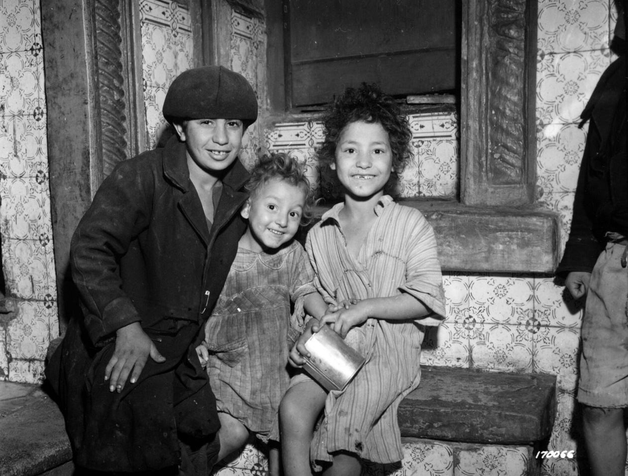
Three Arabic children waiting to receive their daily ration of milk at a distribution point in North Africa. They are allowed 3/4 pint of milk a day, which is distributed by various French agencies and assisted by the American Red Cross.
By European army standards the American rations were lavish to the point of extravagance - vast quantities of tinned meats, fruits and vegetables. In any American mess you could be sure of getting an excellent hot meat and vegetable stew, a plate of fruit, white bread and a cup of coffee.
Things like cigarettes, chewing-gum and toothpaste were handed out in a way that made the British soldiers gape. The Doughboy was always generous in sharing out his good things. As a British war correspondent I personally was given immediate hospitality wherever I went, and such things as maps and plans were discussed with me without hesitation.
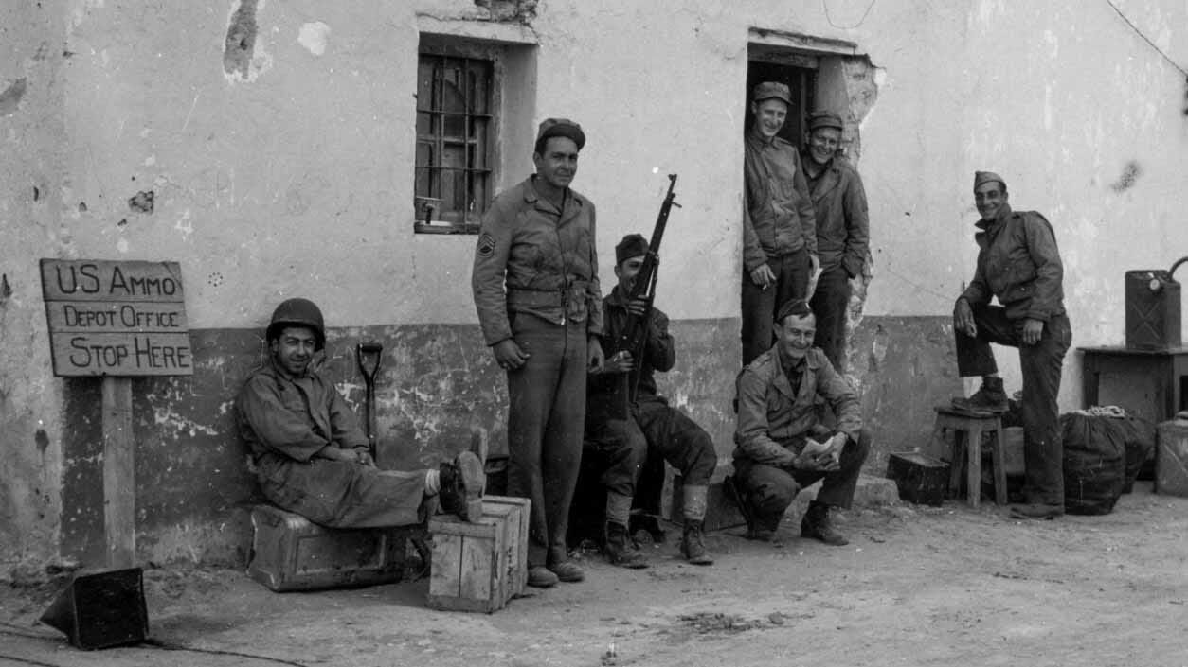
U.S. Army ammunition depot office in North Africa. Crew shown in front of the office.
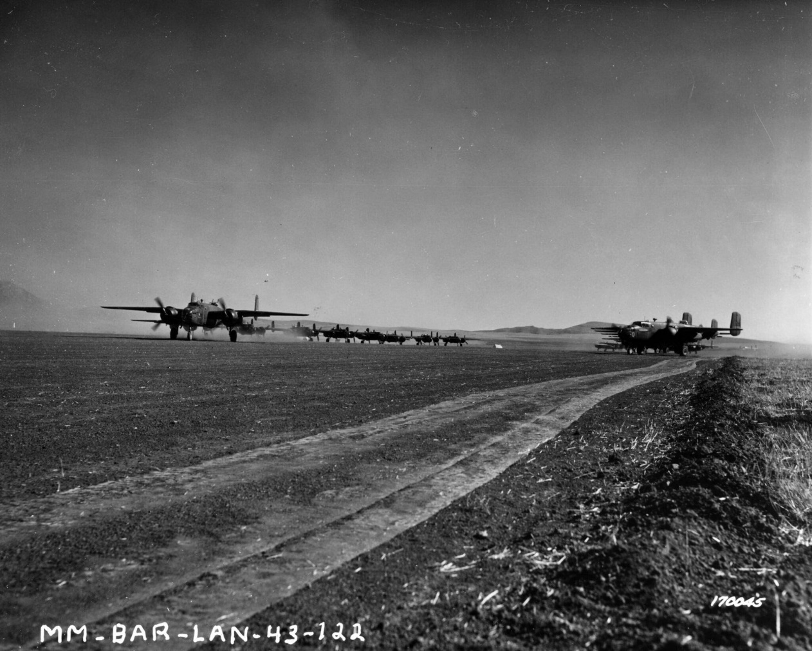
B-25 bombers taking off for a raid. Berteux, North Africa.
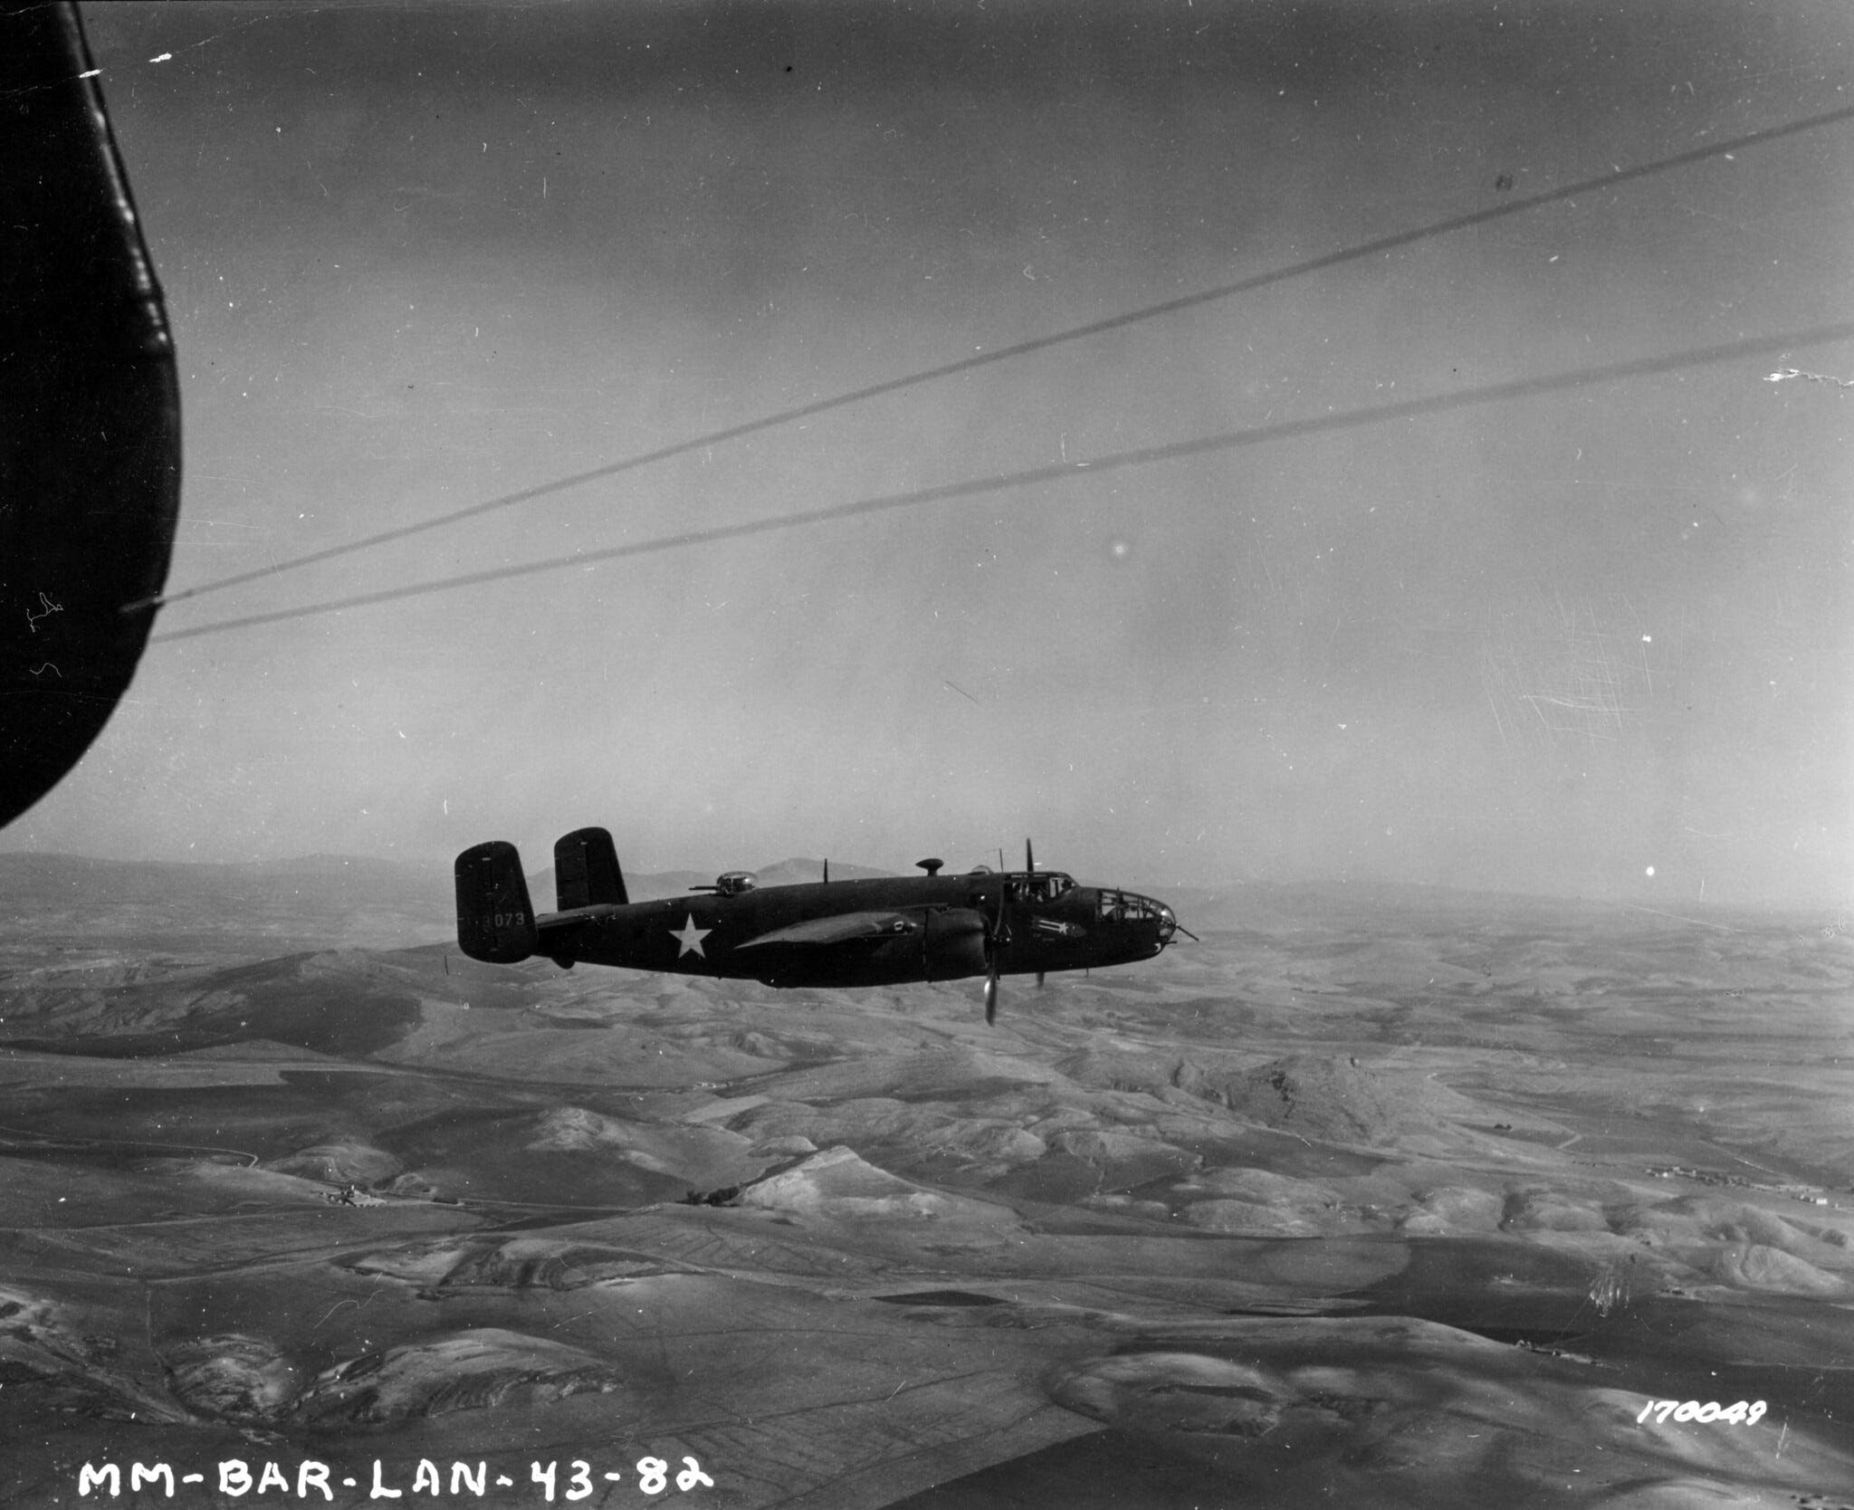
A B-25 bomber on one of its missions.
1
Moorehead: The Desert War Trilogy

